**Project Design Phase-II**

**Data Flow Diagram & User Stories**

|  |  |
| --- | --- |
| Date | 23 October 2022 |
| Team ID | PNT2022TMID19635 |
| Project Name | Project - IoT Based Safety Gadget for Child Safety Monitoring and Notifications. |
| Maximum Marks | 4 Marks |

**Data Flow Diagrams:**

The classic visual representation of how information moves through a system is a data flow diagram (DFD). A tidy and understandable DFD can graphically represent the appropriate quantity of the system demand. It demonstrates how information enters and exits the system, what modifies the data, and where information is kept.

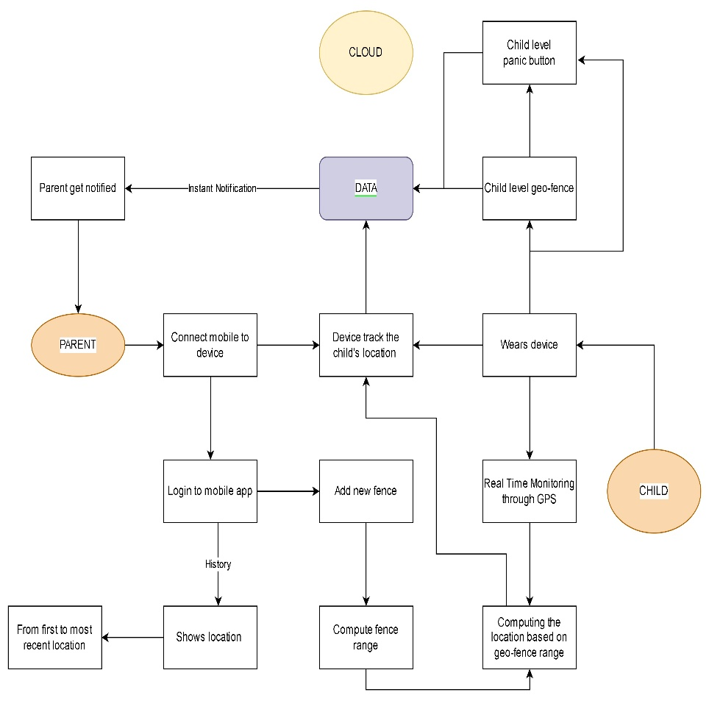

**User Stories**

| **User Type** | **Functional Requirement (Epic)** | **User Story Number** | **User Story / Task** | **Acceptance criteria** | **Priority** | **Release** |
| --- | --- | --- | --- | --- | --- | --- |
| Customer (Mobile user) | Registration | USN-1 | I can sign up for the application as a user by providing my email address, a password, and a password confirmation. | I can get to my dashboard or account. | High | Sprint-1 |
|  |  | USN-2 | When I register for the application as a user, I will get a confirmation email. | I can get confirmation emails and confirm them. | High | Sprint-1 |
|  |  | USN-3 | I can sign up for the application as a user with my Google Account. | I can sign up and use my Google Account to view the dashboard. | High | Sprint-2 |
|  | Login | USN-4 | I can access the application as a user by logging in with my email address and password. |  | High | Sprint-1 |
|  | Dashboard |  | I can always keep an eye on the child's whereabouts as a user. |  | High | Sprint-1 |
| Customer Care Executive | Login |  | I can observe how the application is doing, look for any bugs, keep an eye on things, make sure everyone is permitted, and assist users as needed. | I can log in using the credentials I was given. | Medium | Sprint-3 |